Assessment Schedule – 2014
Physics: Demonstrate understanding of aspects of electricity and magnetism (90937)
Evidence Statement
Question | Achievement | Merit | Excellence
ONE  (a) | Electrons / negative charges build up on the top of the container. | Rubbing / friction causes the electrons / negative charges to be transferred from the woollen cloth to the top container. Hence, it becomes negatively charged.
(b) | Opposite charges attract.  OR  Charges are rearranged within the ball. | Charges are rearranged within each ball. Negative charges on the container repel the negative charges on the balls to the bottom leaving the top of the balls positively charged. Hence, the balls jump to the top. | Charges are rearranged within each ball. Negative charges on the container repel the negative charges on the balls to the bottom leaving the top of the balls positively charged. Opposite charges attract; the negatively charged container now attracts the ball. Hence, the balls jump to the top.
(c) | Metallic balls fall first -metal is conductor.  OR  Uncoated balls stick longer than metallic balls. as they are insulators.  OR  Electrons transfer to ball. | Metallic balls fall first because electrons from the lid are conducted into the balls plus idea of neutralising charge.  OR  Uncoated balls stick longer because electrons are not able to move from the lid to the balls.  OR  Electrons transfer to ball making ball negative. Hence repelled from lid. | (i) Metallic balls fall down first.  (ii) This is because electrons from the lid are conducted into the metal coated balls, making them negatively charged. Since same charges repel, the negatively charged balls are now repelled by the negatively charged container. No electrons are conducted from the lid to the uncoated balls, hence they remain attracted to the lid.  Explains metal balls and compares with polystyrene
(d) | The top of the container is earthed/looses charge so the balls fall down straight away.  OR  electron transfer from lid making it neutral . | Earthing removes electrons from the top of the container and it becomes neutral, hence the balls fall down.

N0 | N1 | N2 | A3 | A4 | M5 | M6 | E7 | E8
No response or no relevant evidence | 1a | 2a OR 1m | 3a | 4a  2m  1e+1a | 2m + 1a | 3m  1e+1m | 1e + 2m | 2e

Question | Achievement | Merit | Excellence
TWO  (a) | Correctly calculates current using  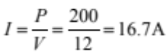 | Correct steps and calculation.  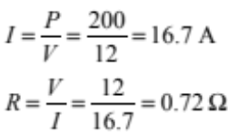
(b) | Either (i) or (ii) is correct. | (i) Correct diagram using correct symbols.  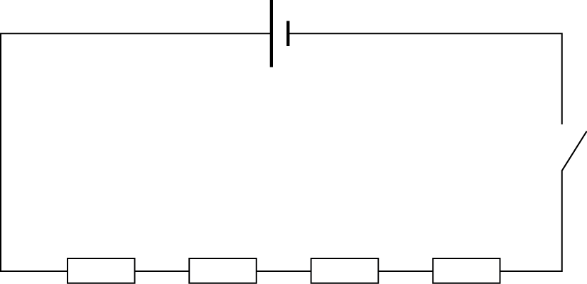  (ii) There is only one path for the current to flow. (The answer ‘the resistors are in series’ is not acceptable.)
(c) | Mentions increased resistance / decreased current for resistors in series.  OR  V splits in series so each element is not at full power. | Loosely links increased resistance / decreased current to decreased power.  Accept the explanation that when in series, the voltage across each element is lower; since P = IV, a lower voltage results in lower power. Hence the total power is less in series connection. | Since the elements are in series, the total resistance increases and so the current will be lower than that in a single element.  Power is P = IV, and the supply voltage is the same, then the power will be lower as current is less.  Hence power cannot be 4 times greater.
(d) | One correct step.  typically total P = 600 W  or one element P = 150 W | Correct calculation given for the energy used by all 4 elements. (72000 J)  OR  Used minutes instead of seconds  to calculate the total energy.  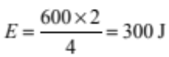  OR  Divides both I and V but uses formulae correctly to give 4500 J. | Power used  P = IV = 240 ⋅ 2.5 = 600 W  Total energy  E = P × t = 600 × (2 × 60)  = 72 000 J  So individual element uses:  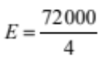  = 18 000 J (= 18 kJ)  OR  Calculates the power for one element as 150 W then uses the equation E = P × t to calculate the energy.

N0 | N1 | N2 | A3 | A4 | M5 | M6 | E7 | E8
No response or no relevant evidence | 1a | 2a OR 1m | 3a | 4a  2m  1e+1a | 2m + 1a | 3m  1e+1m | 1e + 2m | 2e

Question | Achievement | Merit | Excellence
THREE  (a) | Correct working, but using the distance in cm to get answer of 3.2 ⋅ 10^{–8} T.  Or correct answer for incorrect conversion to m | Correct working and answer.  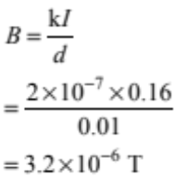
(b) | Calculated the correct voltage as 12 V.  OR  Voltage across coil A as 5.12 V. | Calculated the correct total resistance as 75 Ω.  OR  Power of coil B as 1.1 W. | Correct working and answer for R_{B}.  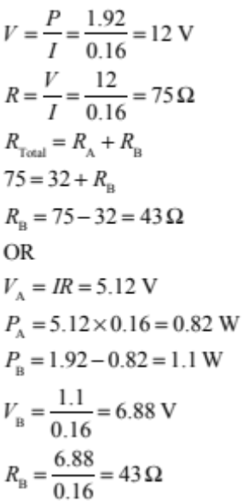
(c) | One of the ideas is implied. For example, when the switch is closed, the current flows through the coil and it becomes a magnet. | Two ideas are implied. For example the electromagnet becomes magnetised when the current flows through the circuit and they attract the striker towards them to sound the bell. | Demonstrates understanding of the working of the bell.  (i) When the switch is pressed the circuit is complete and current flows through the coil. The soft iron core becomes magnetised and attracts the moving arm.  (ii) As the moving arm is pulled away from the contact screw, the hammer strikes the bell, and the circuit is incomplete. And the current flow stops.  (iii) The soft iron core is no longer magnetised, and so the moving arm is pulled back to its original position.  (iv) Now the circuit is once more complete and the cycle begins again.
(d) | Correct diagram.  OR  Correct explanation – can be compass without direction or iron filings to show shape of field. | (i) Correct field shape and direction are given.  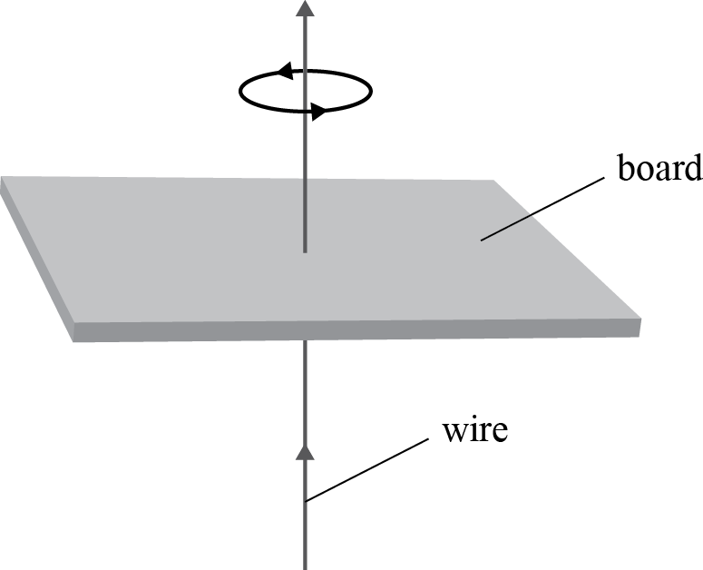  (ii) Place a compass on the card. The direction in which the north end of the compass needle points is the direction of the magnetic field at that point.

N0 | N1 | N2 | A3 | A4 | M5 | M6 | E7 | E8
No response or no relevant evidence | 1a | 2a OR 1m | 3a | 4a  2m  1e+1a | 2m + 1a | 3m  1e+1m | 1e + 2m | 2e

Cut Scores
 | Not Achieved | Achievement | Achievement with Merit | Achievement with Excellence
Score range | 0 – 6 | 7 – 14 | 15 – 20 | 21 – 24

